Name __________________________

Murder! Mystery and Mayhem in the Library
Information Literacy Lesson
by Lynn M. Brown

Task #1:
Look at the library map. There are three main areas or classrooms within the library. Write down their names below:

1. ____________________________________

2. ____________________________________

3._____________________________________

What area of the library are you in right now? _______________________________________________

Task #2:

On your library treasure map locate the following by circling the item:

  - Atlas
  - Dictionaries
  - Circulation Desk
  - Newspapers/Magazines
  - Printers
  - Nemo the fish

Task #3:

Find the following information:

- What is the name of the dictionary on the dictionary stand? _________________________
- On what page in the atlas is Transylvania located on? ____________________
- Name one thing that is done at the circulation desk. ___________________________
- Give the name of one set of encyclopedias the library has other than World Book Encyclopedia.
______________________________________________________

The library contains Fiction, Non-Fiction, Reference, and Biography sections. These are labeled with yellow arrows on the map below:

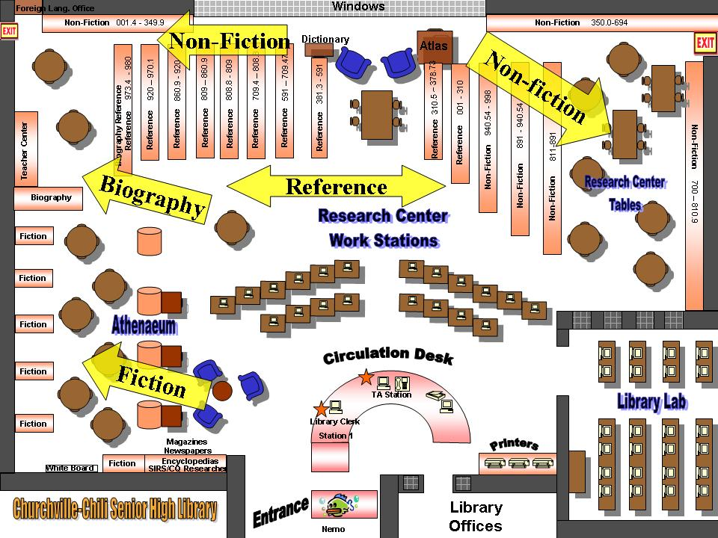

Task #5:

By looking at the "murder" search results screen, answer the following questions:

- Who is the author of the book "The trial of Sacco and Vanzetti?"

_____________________________________________________

- What year was the book "The O.J. Simpson trial: what is shows us about our legal system" published in?

_____________________________________________________

- What is the call number of the book written by Joan Axelrod-Contrada?

_____________________________________________________

Task #6:
If a book was written about you. What would the call number look like?

_________________________________________________________

Task #7:

With your group, use the OPAC system to find one book from each type listed below that has something to do with your assigned topic:

- Fiction
- Non-fiction
- Reference
- Biography

Bring your books along with the OPAC printout of each book to the circulation desk when you are finished.

